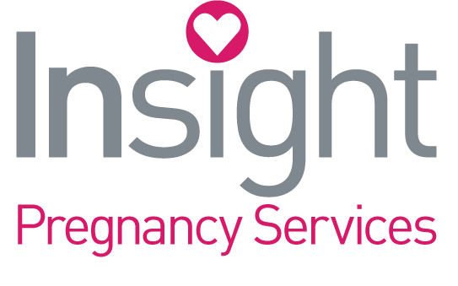
Who We Are

Insight Pregnancy Services is a life-affirming, faith-based pregnancy resource center serving those who find themselves in an unplanned pregnancy, traumatized by abortion and other sexual trauma, or needing parenting support and education.
The work was begun in 2000 in Newaygo, Michigan as a satellite office of the Grand Rapids Alpha Women’s Center, as a result of the vision of the First Baptist Church of Newaygo to have a pregnancy resource center to serve Newaygo County. The center was first opened in a residential building on Wood Street in Newaygo. In the years to follow the ministry moved two times to larger offices to accommodate growth.
In 2007 the Newaygo satellite office became an independent center, with its own Board of Directors and incorporated as a 501(C)(3) non-profit religious, educational organization.
Finally, in 2012 land was purchased and a more than adequate facility was built. In 2018 the ministry was relocated to Fremont, MI where a building was purchased and renovated for cash, making the ministry debt free. The new office, a gift from God, is in a prime location in Newaygo County for reaching the age demographic that we work to attract; 15 -24 years old.
The services of Insight Pregnancy Services are always free to everyone. Services include: Pregnancy options counsel, material and educational support for parenting, adoption support, relationship education for healthy sexual choices, healing from sexual abuse and trauma, post-abortion recovery and our newest addition – Insight 4 Dads fatherhood program added in 2017.
Funding comes through the generosity of local individuals, churches, businesses and foundations. Insight is a non-denominational outreach of every local church who partners with us. Being volunteer driven, one of the primary partnerships with the local church is volunteering of church members. There are many volunteer opportunities.
Together, since our inception we have served over 10,000 young women and men.
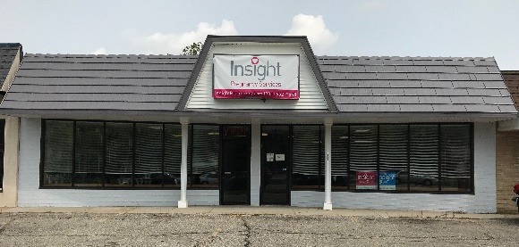
Contact Us:
231.335.2413
www.InsightPregnancy.com
Currently housed in our new facility at
1007 W. Main St. Fremont

